Model Research

Project title: AI Response Quality Evaluator Agent
The project aims to evaluate AI-generated responses automatically using LLM-as-a-Judge techniques, evidence retrieval, and multiple specialized evaluation agents. The system assesses relevance, factual accuracy, hallucination risk, and completeness, then combines the results into an explainable quality verdict.

Research area
A. LLM-as-a-Judge - A large language model evaluates another model's response using a predefined rubric. It can provide numerical scores, explanations, and identified errors.
Application: Power the relevance, accuracy, completeness, and verdict agents.
Limitation: The judge can also make mistakes or show bias, so its results must be tested against human-labelled examples.

B. Hallucination detection - The system breaks an answer into factual claims and checks whether each claim is supported by reference evidence.
Application: Flag unsupported claims, contradicted statements, and claims that cannot be verified.
Limitation: Missing evidence does not automatically prove a statement is false.

C. Retrieval-Augmented Generation (RAG) - RAG retrieves relevant passages from reference documents and supplies them as context to the evaluator.
Application: Ground accuracy and hallucination assessments in available evidence.
Limitation: Poor document quality or retrieval can lead to incorrect evaluations.

D. Evaluation metrics - The system measures response relevance, accuracy, completeness, factual grounding, and final verdict quality.
Application: Produce individual scores, explainable verdicts, and batch-level analytics.

Existing evaluation frameworks
Framework | Main purpose | How it helps to our project
RAGAS | Evaluates RAG and LLM applications using metrics | Guides faithfulness, response relevance, and factual correctness metrics.
TruLens | Evaluates LLM applications using feedback and metrics | Guides relevance and groundedness evaluation.
LLM-as-a-Judge | Uses an LLM to score another model's output | Provides the basis for your five judge agents.

Model selection
We need three types of models or components:
Component | Recommended choice | Reason
Judge model | Gemini API or another accessible instruction-following LLM | Generates structured scores and explanations
Embedding model | sentence-transformers/all-MiniLM-L6-v2 | Converts text into numerical vectors for semantic retrieval
Vector index | FAISS | Searches for relevant document chunks efficiently

System Architecture
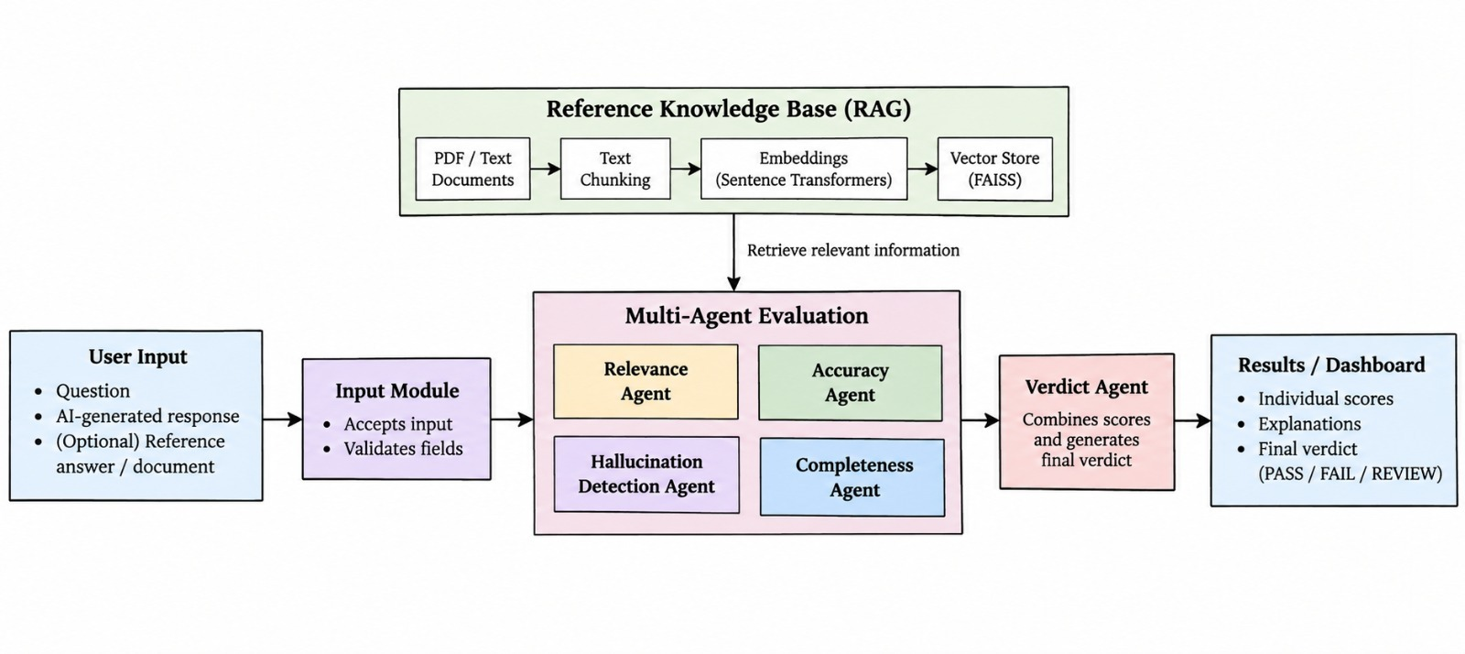
- User Input
The user provides three things:
- Question asked to the AI.
- AI-generated response that needs to be evaluated.
- Optional reference answer or source document to verify the response.
- Input Module
This module accepts the user's input and validates it. It checks whether the question and AI response are provided and processes the optional reference answer or document.
- Reference Knowledge Base (RAG)
This component retrieves relevant information from reference documents to help evaluate the AI response.

It contains four stages:
- PDF/Text Documents: The source information used for verification.
- Text Chunking: Splits long documents into smaller sections.
- Embeddings: Sentence Transformers converts the text chunks into numerical vectors representing their semantic meaning.
- Vector Store (FAISS): Stores the vectors and retrieves relevant passages for a given query.
The retrieved passages are provided to the evaluation agents as evidence. If the user supplies a reference answer instead of a document, the system can also compare the response directly against that answer.
- Multi-Agent Evaluation
This is the main part of your project. Four specialized agents evaluate different aspects of the AI-generated response.

Agent | Responsibility
Relevance Agent | Checks whether the response answers the user's question.
Accuracy Agent | Checks factual correctness against the available reference.
Hallucination Detection Agent | Identifies claims that are unsupported by or contradict the source evidence.
Completeness Agent | Checks whether important information is missing.

Each agent produces a score and an explanation of its findings. These agents can use the same underlying LLM while following different evaluation instructions.
- Verdict Agent
The Verdict Agent receives the results from all four agents. It combines their scores using predefined weights and applies the project's decision rules to generate the final verdict.

Possible verdicts are:
- PASS: The response meets the defined quality criteria.
- FAIL: The response fails important quality or factual-grounding criteria.
- REVIEW: The evidence is insufficient or the result needs human verification.
The thresholds and rules must be defined and tested; they should not be chosen arbitrarily.
- Results / Dashboard
The dashboard displays the final evaluation to the user, including individual scores, explanations, detected issues, supporting evidence, and the overall verdict. Later, it can also display batch evaluation results and quality trends across multiple responses.

What are the technologies doing?
- Streamlit: Creates the webpage where the user enters the question and answer.
- Python: Connects all the modules and agents.
- LLM API: Powers the judge agents that evaluate the response.
- Sentence Transformers: Converts reference text into numerical vectors called embeddings.
- FAISS: Finds reference passages that are semantically similar to the query.
- Pandas and Plotly: Process batch results and display charts.

